CSA1023-Software Engineering

                                   Question8

8). You are tasked with developing an Online Learning Platform. The

platform should include the following functionalities:

1. Course Enrollment and Registration

2. Video Lecture Streaming

3. Interactive Quizzes and Assignments

4. Progress Tracking Dashboard

5. Peer-to-Peer Discussion Forums

6. Certificate Generation

Use Jira to categorize and prioritize these requirements using

MoSCoW and Kano techniques.

**Step 1: Set Up Your Jira Project:-**

* Log into Jira and create a new project.
* Choose a project template - Scrum
* Name the project  **Online Learning Platform**.

**2). Define Project Components:-**

* Course Enrollment and Registration
* Video Lecture Streaming
* Interactive Quizzes and Assignments
* Progress Tracking Dashboard
* Peer-to-Peer Discussion Forums
* Certificate Generation.

**3). Update User Stories with MoSCoW Priorities:-**

* Course Enrollment and Registration: Must Have
* Video Lecture Streaming: Must Have
* Interactive Quizzes and Assignments: Should Have
* Progress Tracking Dashboard: Should Have
* Peer-to-Peer Discussion Forums: Could Have
* Certificate Generation: Should Have

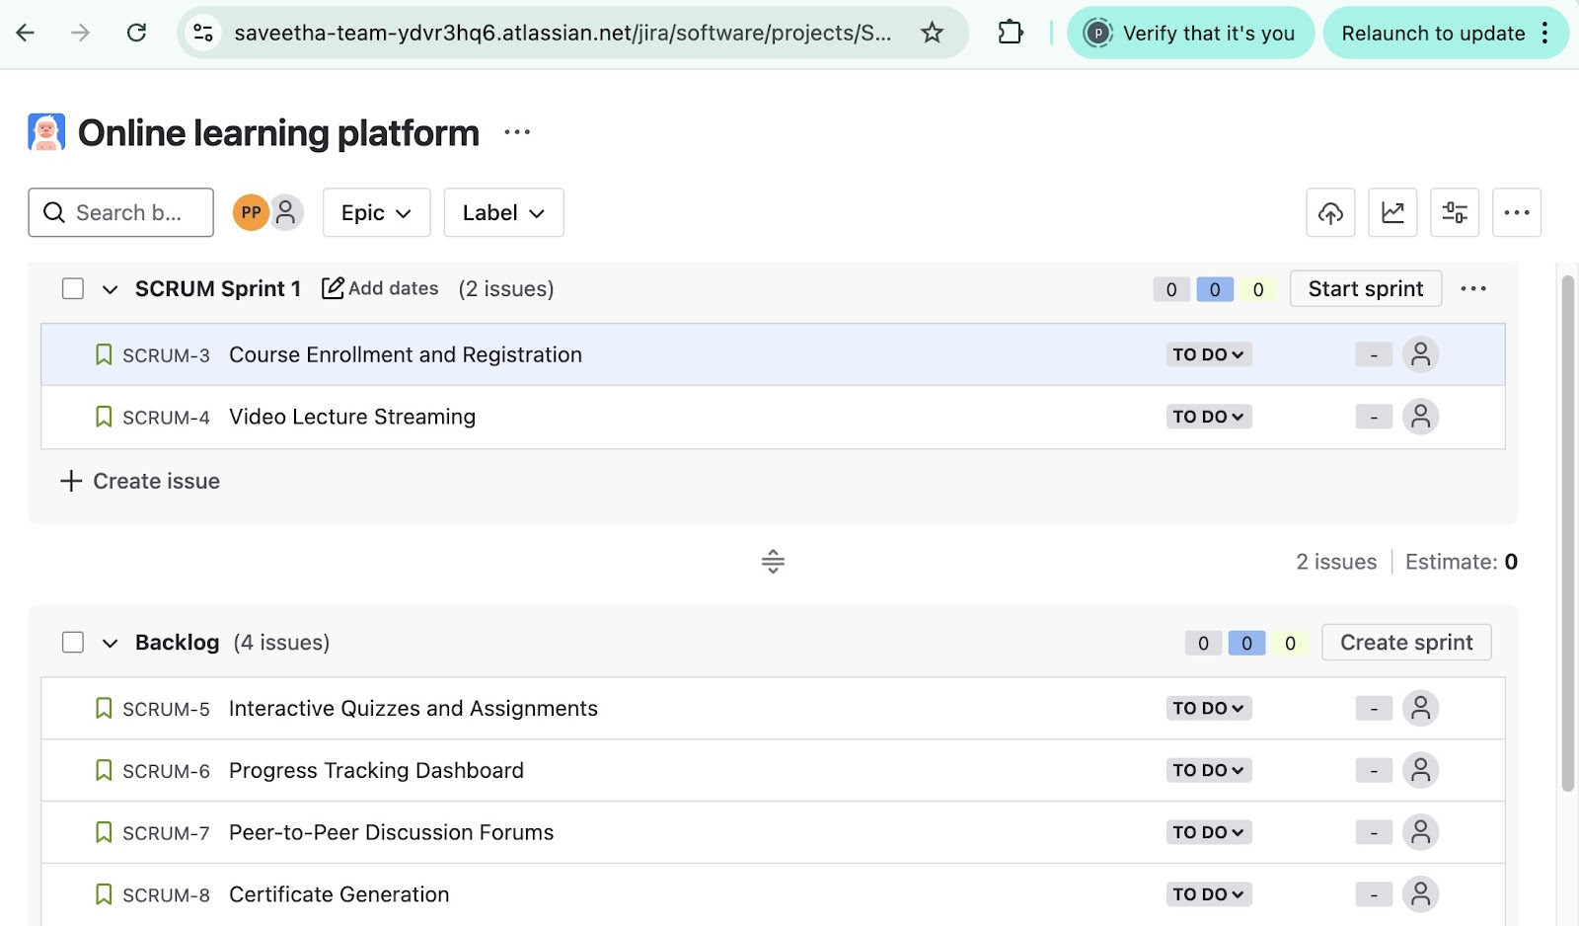

**4). Drag and drop backlogs into sprint:-**

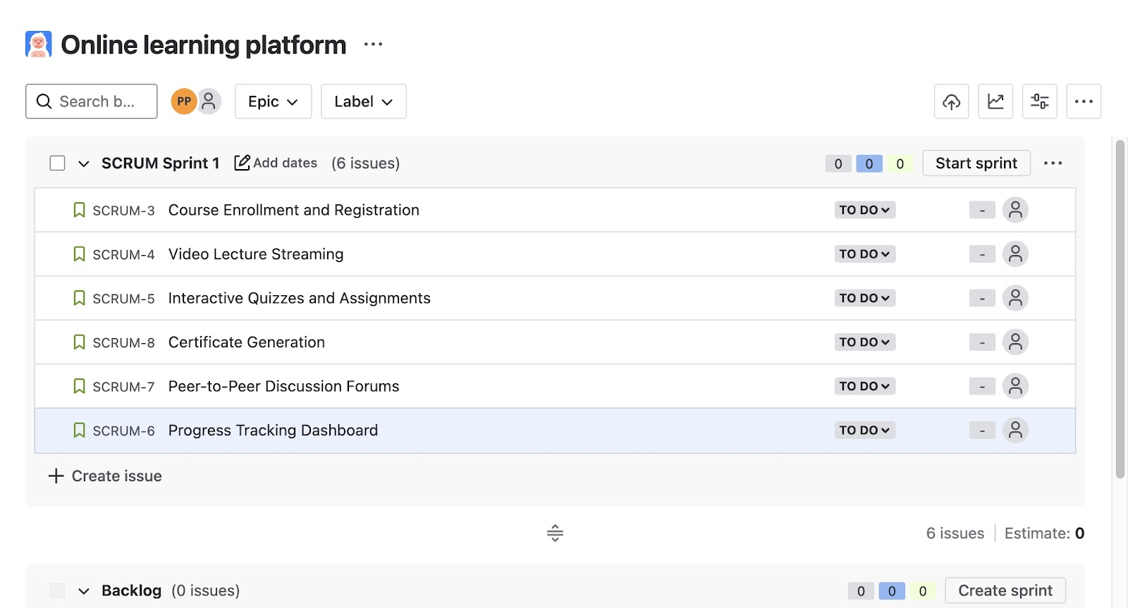

**5). Start sprint to complete the backlogs:-**

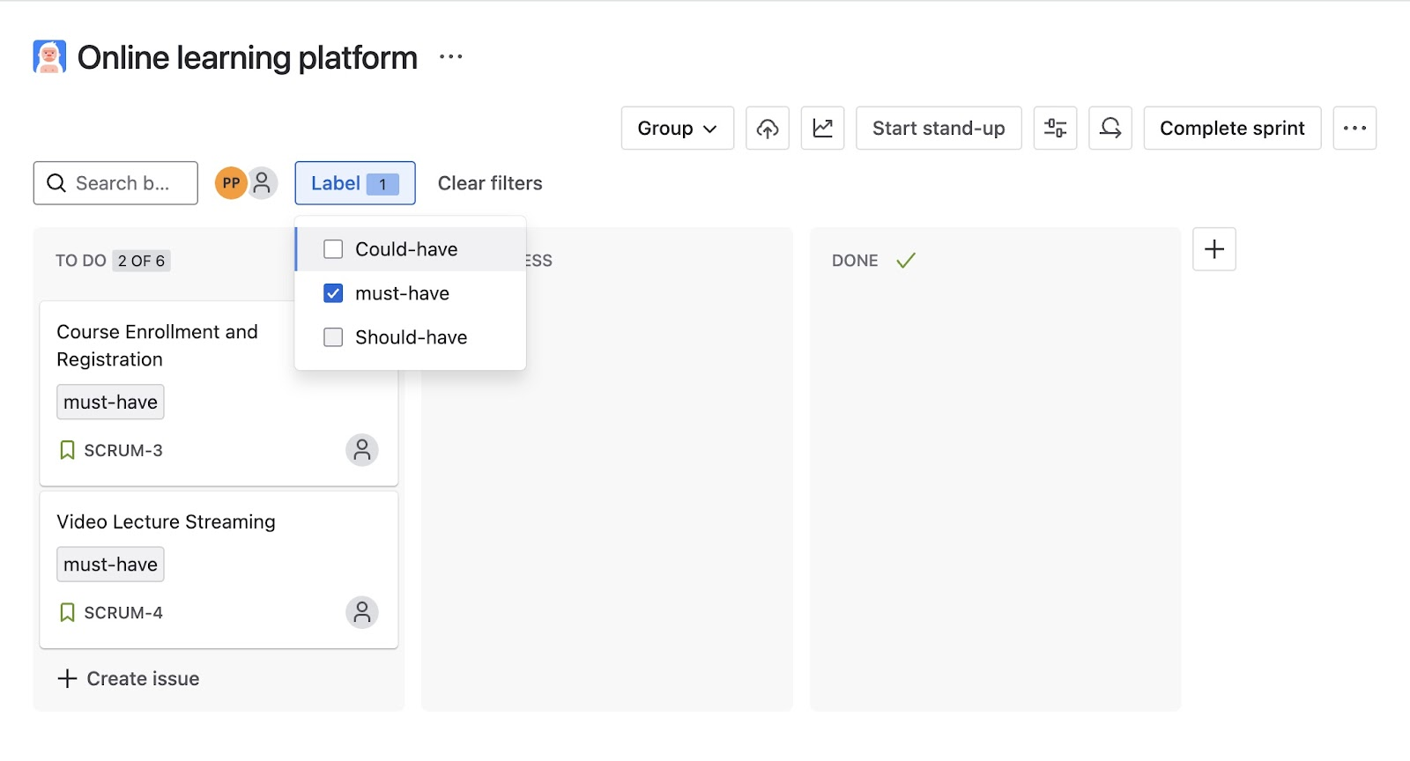

These can be categorized into MoSCoW priorities.

**6). Complete the task:-**

Once the backlogs are completed the work status is mentioned to be in done status**.**

